* **CONVOLUTION  
    
  Lab1 Task**

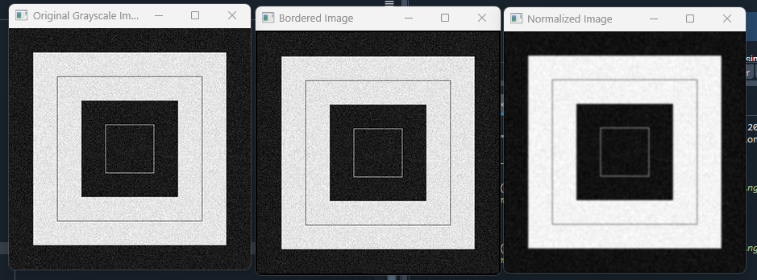

Figure 1.1: Applying convolution on a image with given kernel

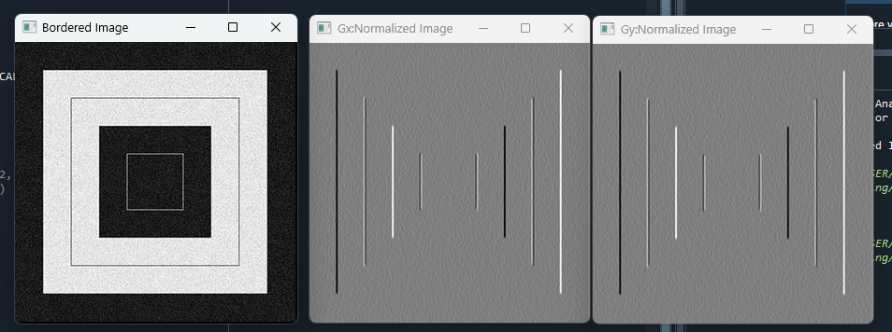

Figure 1.2:Convolution using Prewitt operator, kernel center(0,0)

* **Assignment**

**RGB vs HSV Channel**

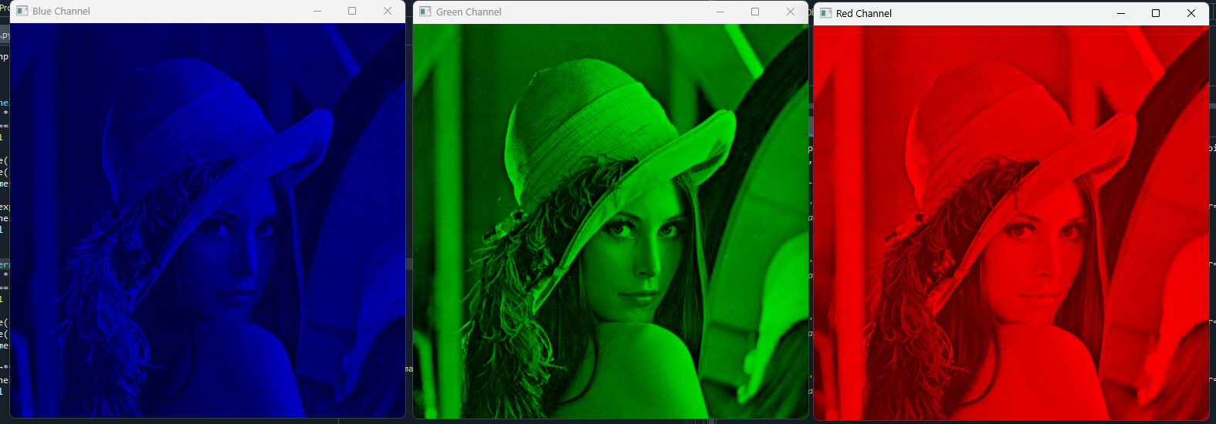

Figure: RGB channel

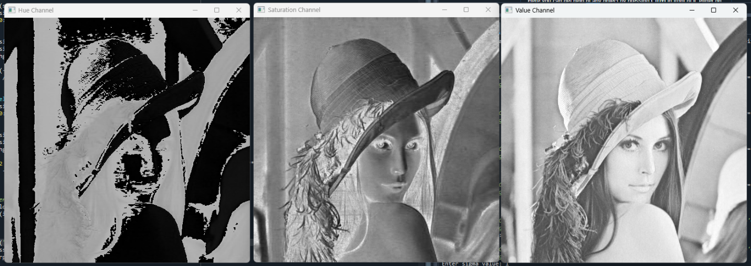

Figure : HSV channel

HSV separates image information into Hue, Saturation, and Value, making it easier to adjust brightness and color independently while preserving natural appearance.

**RGB Gaussian vs HSV Gaussian**

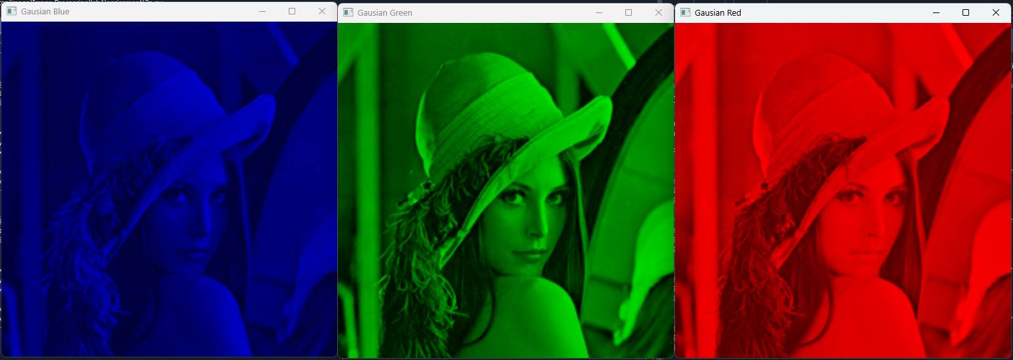figure: RGB Gaussian 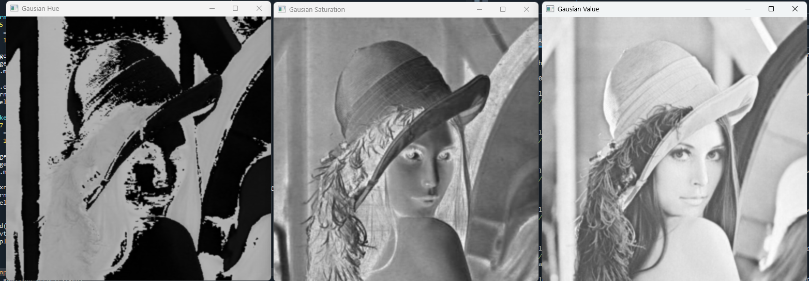figure: HSV GaussianRGB Gaussian smoothing reduces noise but can blur colors and edges since it acts on each channel directly.  
HSV Gaussian smoothing mainly softens brightness and saturation variations

**RGB Sharpening vs HSV Sharpening  
  
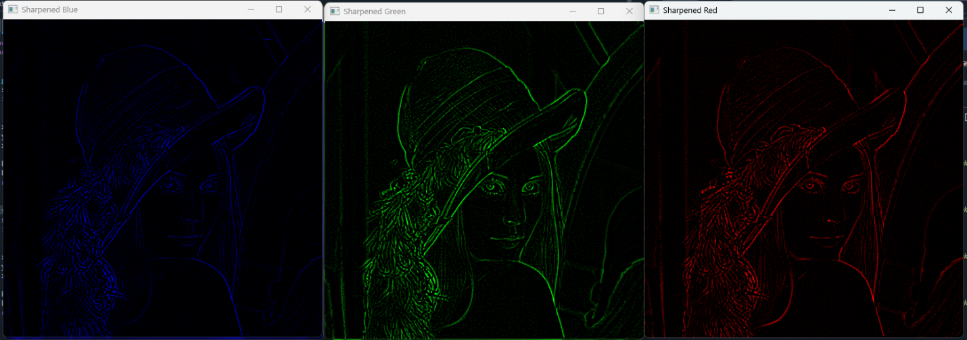**

figure: RGB sharpened images

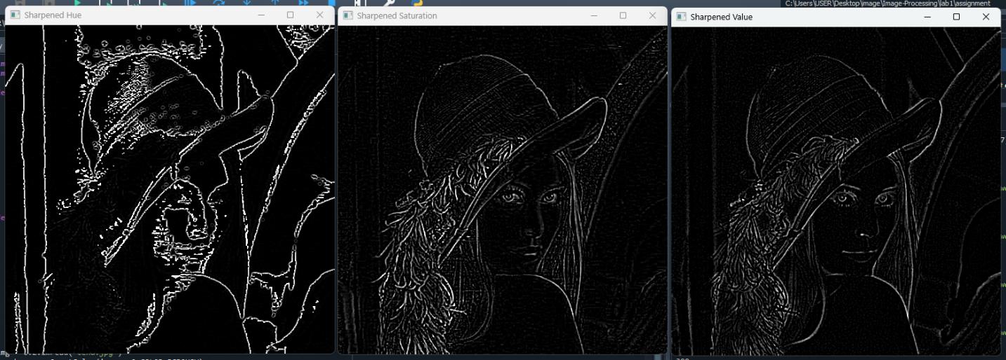figure: HSV sharpened imagesRGB sharpening enhances edges but may introduce color artifacts due to independent channel processing.  
HSV sharpening sharpens mainly in the Value channel, preserving natural colors while improving edge clarity.

**RGB vs HCV merged Gaussian and Sharpened Image**

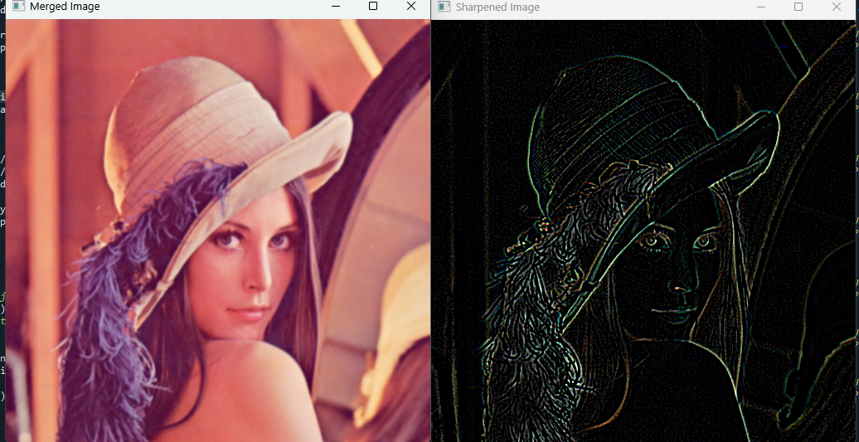figure: RGB merged Gaussian and Sharpened Images

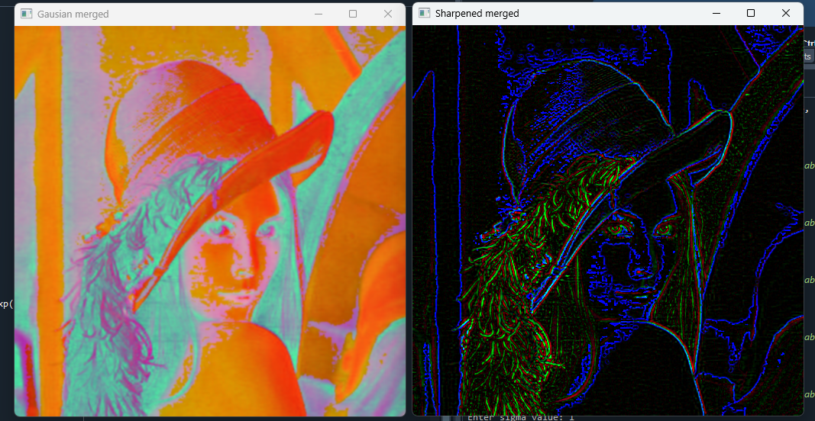figure: HCV merged Gaussian and Sharpened Images

RGB merged Gaussian and sharpened images directly modify all three color channels, often causing slight color distortion along with smoothing or edge enhancement.  
HSV merged Gaussian and sharpened images operate mainly on brightness (Value), producing smoother and sharper results while preserving natural color appearance.

**CSE 4128: Image Processing and Computer Vision Laboratory**

**Assignment No:01**

**Assignment Name: Convolution**

**By**

**Md Rauful Islam Tamim**

Roll: 2007009



**Department of Computer Science and Engineering**

**Khulna University of Engineering & Technology**

**Khulna 9203, Bangladesh**

**August, 2025**